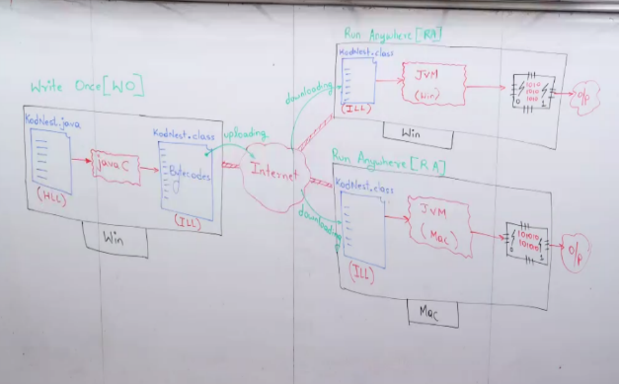Wora satanda for write once runs anyware.

Architecture neutral means java can be compiled & interpreted anywhere.

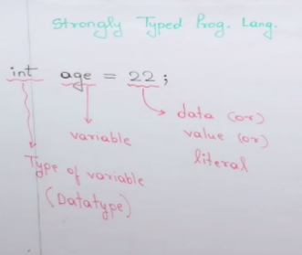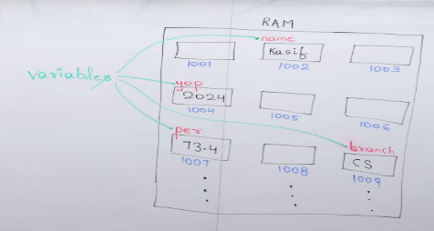

Creating variables in java:

|  |
| --- |
| **Incr/decr** |

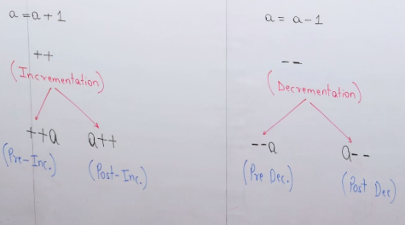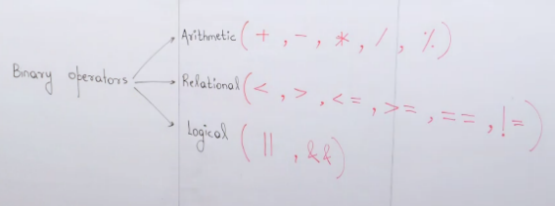Java is considered as strongly typed programming language which means in java it’s mandatory to provide the type of variables (or)datatypes.

Types of operators :3 types 1. Unary 2. Binary 3. Ternary

1.binary operators: these are such operators which requires

at least two operands to perform the tasks. Three types:

EX: - **Program.java** (arithmetic opt)

**Relation.java`**

Unary Operators:

It requires single operand for performing the operations, they are below mention Unary Operators.

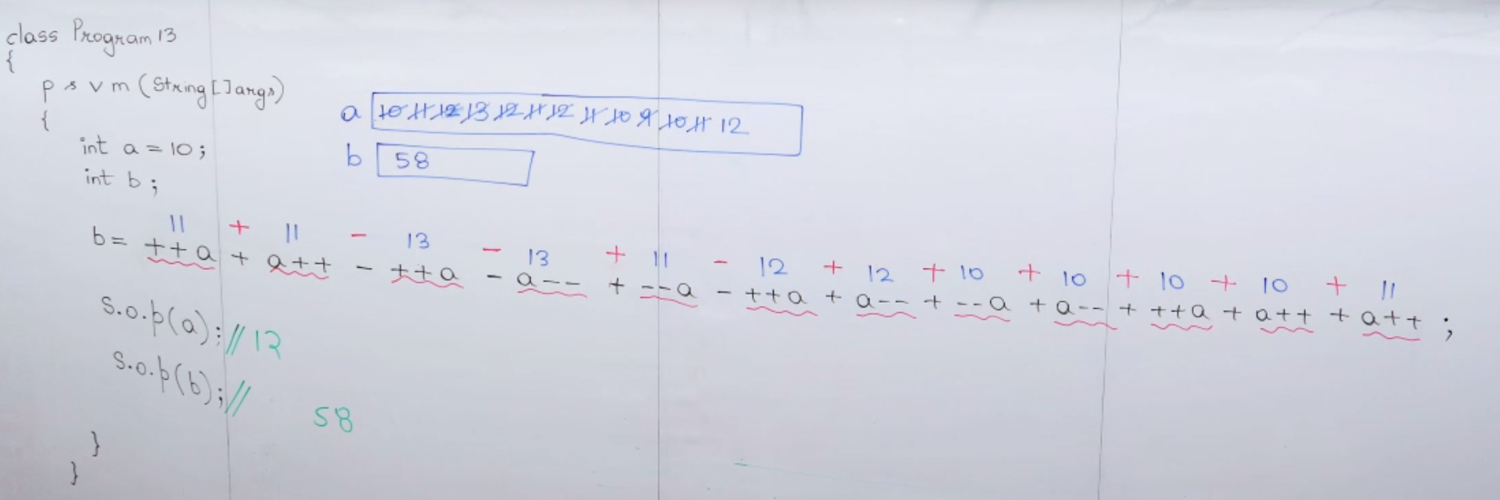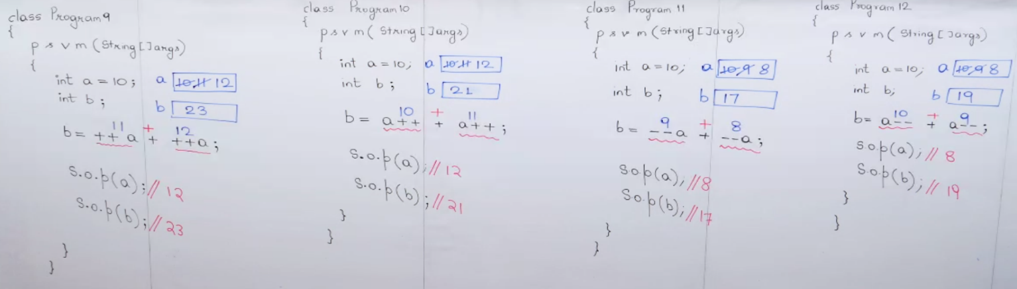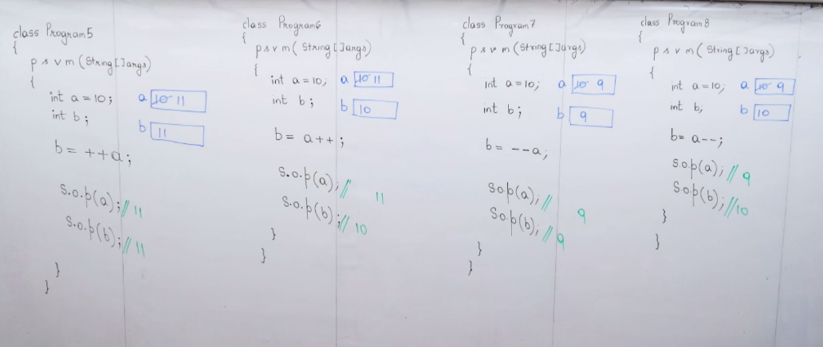Types of increment /decrements: (++ Pre, Post++, --Pre, Post--)